24CSI024L-DATA STRUCTURE AND ALGORITHMS
C PROGRAMMING LABORATORY RECORD

Name: BHARATHWAJ M A
Register No: 25BAD017
Date: 24/07/26

Experiment 1: Squaring a Sorted Array (Two-Pointer Technique)

Aim
To write a C program that accepts a sorted array (which may contain negative values) and produces a new array containing the squares of every element, arranged in non-decreasing order, using the two-pointer technique in O(N) time.
Algorithm / Pseudocode
- Read N and the N sorted integers into an array arr.
- Initialise left = 0 and right = N - 1. Create an output array result of size N and a fill position pos = N - 1.
- While left <= right, compare |arr[left]| and |arr[right]|.
- If |arr[left]| is greater, place arr[left]*arr[left] at result[pos], then increment left.
- Otherwise, place arr[right]*arr[right] at result[pos], then decrement right.
- Decrement pos after every placement and repeat until the array is filled.
- Print the result array.
C Program
int arr[10000], result[10000];
for (int i = 0; i < n; i++) {
scanf("%d", &arr[i]);
}
#include <stdio.h>
#include <stdlib.h>

int main() {
int n;
scanf("%d", &n);

int left = 0, right = n - 1;
int pos = n - 1;

while (left <= right) {
int leftAbs = abs(arr[left]);
int rightAbs = abs(arr[right]);

if (leftAbs > rightAbs) {
result[pos] = leftAbs * leftAbs;
left++;
} else {
result[pos] = rightAbs * rightAbs;
right--;
}
pos--;
}

for (int i = 0; i < n; i++) {
printf("%d", result[i]);
if (i != n - 1) printf(" ");
}
printf("\n");

return 0;
}
Sample Input
5
8 5 9 1 4

Sample Output
1 16 81 25 64
OUTPUT :

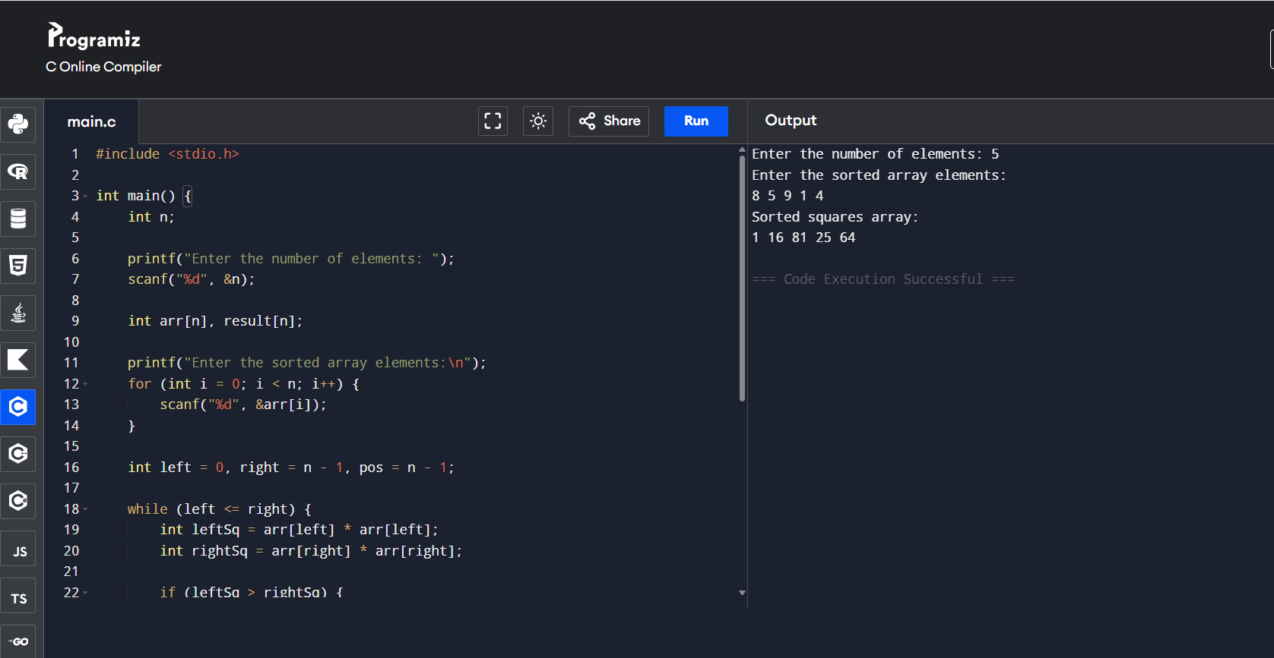

Result: The program correctly squares every element of the sorted seismic-intensity array and produces the output in non-decreasing order using O(N) time and O(N) extra space, verified against the sample output.

Experiment 2: Cumulative Resource Consumption (Prefix Sum)

Aim
To write a C program that computes the prefix sum array of hourly data-packet logs, representing the cumulative data transmitted up to each hour.

Algorithm / Pseudocode

- Read N and the N hourly packet values into an array arr.
- Create a prefix array P of size N and set P[0] = arr[0].
- For i from 1 to N - 1, compute P[i] = P[i - 1] + arr[i].
- Print the prefix sum array P.

C Program
#include <stdio.h>

int main() {
int n;
scanf("%d", &n);

long long arr[10000], prefix[10000];
for (int i = 0; i < n; i++) {
scanf("%lld", &arr[i]);
}

prefix[0] = arr[0];
for (int i = 1; i < n; i++) {
prefix[i] = prefix[i - 1] + arr[i];
}

for (int i = 0; i < n; i++) {
printf("%lld", prefix[i]);
if (i != n - 1) printf(" ");
}
printf("\n");

return 0;
}

Sample Input

5
100 200 150 300 250

Sample Output

100 300 450 750 1000

OUTPUT:

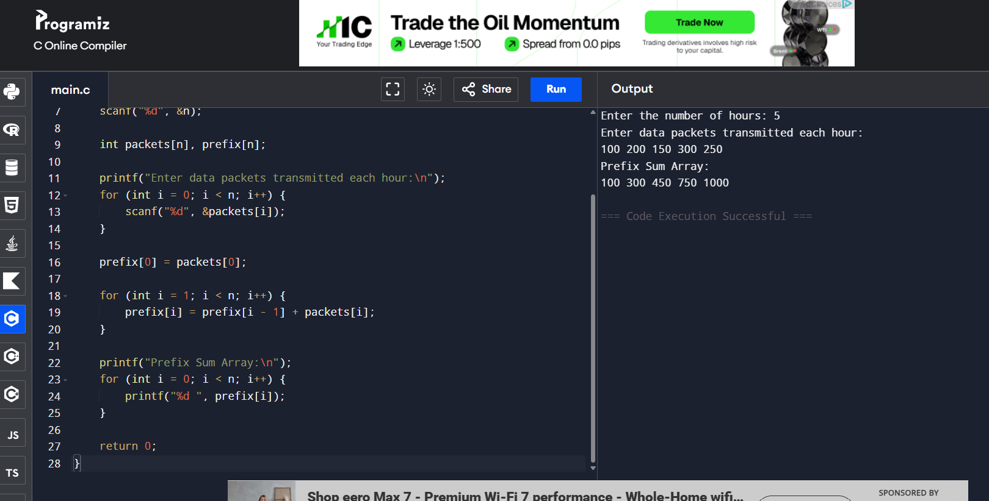

Result: The program successfully generates the hourly cumulative usage report by computing the prefix sum array in O(N) time, matching the expected output for the given sample data

Experiment 3: Grouping Active Sectors (Fixed-Size Sliding Window)

Aim

To write a C program that finds the minimum number of swaps required to group all active sectors (1s) together in a binary array, using a fixed-size sliding window.
Algorithm / Pseudocode

- Read N and the N binary values into an array arr. Count the total number of 1s and store it as C.
- If C is 0 or 1, no swaps are needed; print 0 and stop.
- Compute the number of 1s in the first window of size C; store this as the initial windowOnes and set maxOnes = windowOnes.
- Slide the window across the array: for each new index i included, add 1 if arr[i] is 1; for the index leaving the window (i - C), subtract 1 if it was 1
- Update maxOnes whenever windowOnes exceeds the current maxOnes.
- The minimum swaps required = C - maxOnes. Print the result.

C Program
#include <stdio.h>

int main() {
int n;
scanf("%d", &n);

int arr[10000];
int countOnes = 0;
for (int i = 0; i < n; i++) {
scanf("%d", &arr[i]);
if (arr[i] == 1) countOnes++;
}

if (countOnes <= 1) {
printf("Min Swaps: 0\n");
return 0;
}

int windowOnes = 0;
for (int i = 0; i < countOnes; i++) {
if (arr[i] == 1) windowOnes++;
}

int maxOnes = windowOnes;

for (int i = countOnes; i < n; i++) {
if (arr[i] == 1) windowOnes++;
if (arr[i - countOnes] == 1) windowOnes--;
if (windowOnes > maxOnes) maxOnes = windowOnes;
}

printf("Min Swaps: %d\n", countOnes - maxOnes);

return 0;
}
Sample Input
7
1 0 1 0 1 0 1
Sample Output
Min Swaps: 2
OUTPUT:

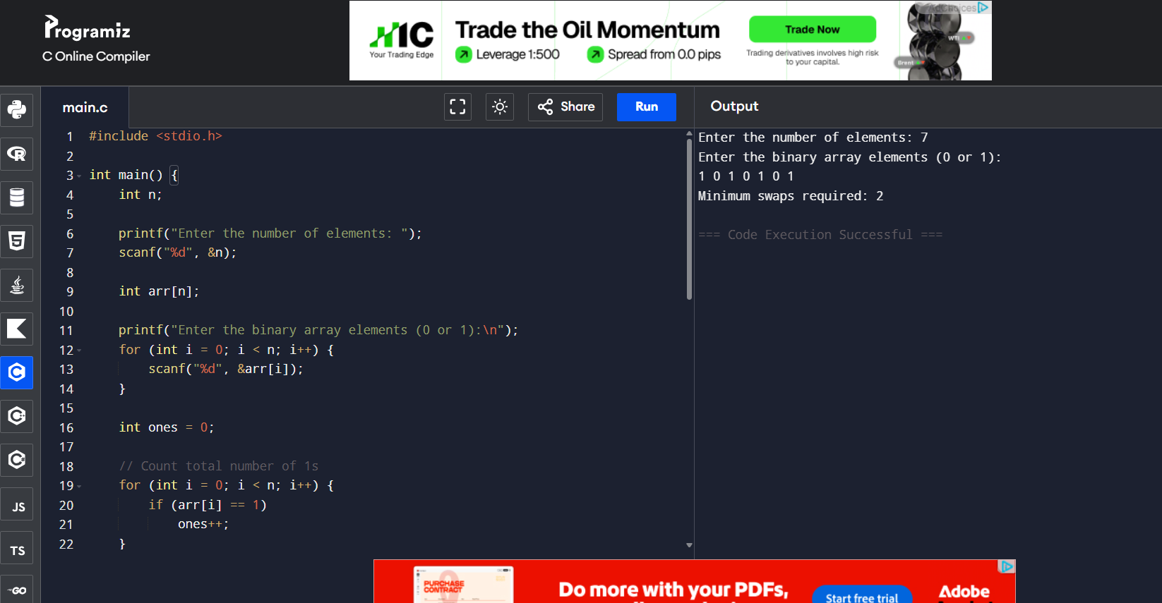

Result: The program correctly determines the minimum number of swaps needed to group all active sectors together, running in O(N) time using a fixed-size sliding window of size C.

Experiment 4: Maximum Task Window Within Budget (Variable-Size Sliding Window)

Aim

To write a C program that finds the maximum number of consecutive tasks that can be executed without their combined energy cost exceeding a given power limit P, using a variable-size sliding window.

Algorithm / Pseudocode

- Read N, P and the N positive energy-cost values into an array arr.
- Initialise start = 0, currentSum = 0 and maxLen = 0.
- For end from 0 to N - 1, add arr[end] to currentSum.
- While currentSum exceeds P, subtract arr[start] from currentSum and increment start.
- Compute the current window length as end - start + 1 and update maxLen if it is larger.
- After the loop, print maxLen as the maximum consecutive tasks.

C Program
#include <stdio.h>

int main() {
int n;
long long p;
scanf("%d %lld", &n, &p);

long long arr[10000];
for (int i = 0; i < n; i++) {
scanf("%lld", &arr[i]);
}

int start = 0;
long long currentSum = 0;
int maxLen = 0;

for (int end = 0; end < n; end++) {
currentSum += arr[end];

while (currentSum > p) {
currentSum -= arr[start];
start++;
}

int windowLen = end - start + 1;
if (windowLen > maxLen) maxLen = windowLen;
}

printf("Max Length: %d\n", maxLen);

return 0;
}
Sample Input

6

2 1 3 2 1 1
Sample Output

Max Length: 3

OUTPUT:

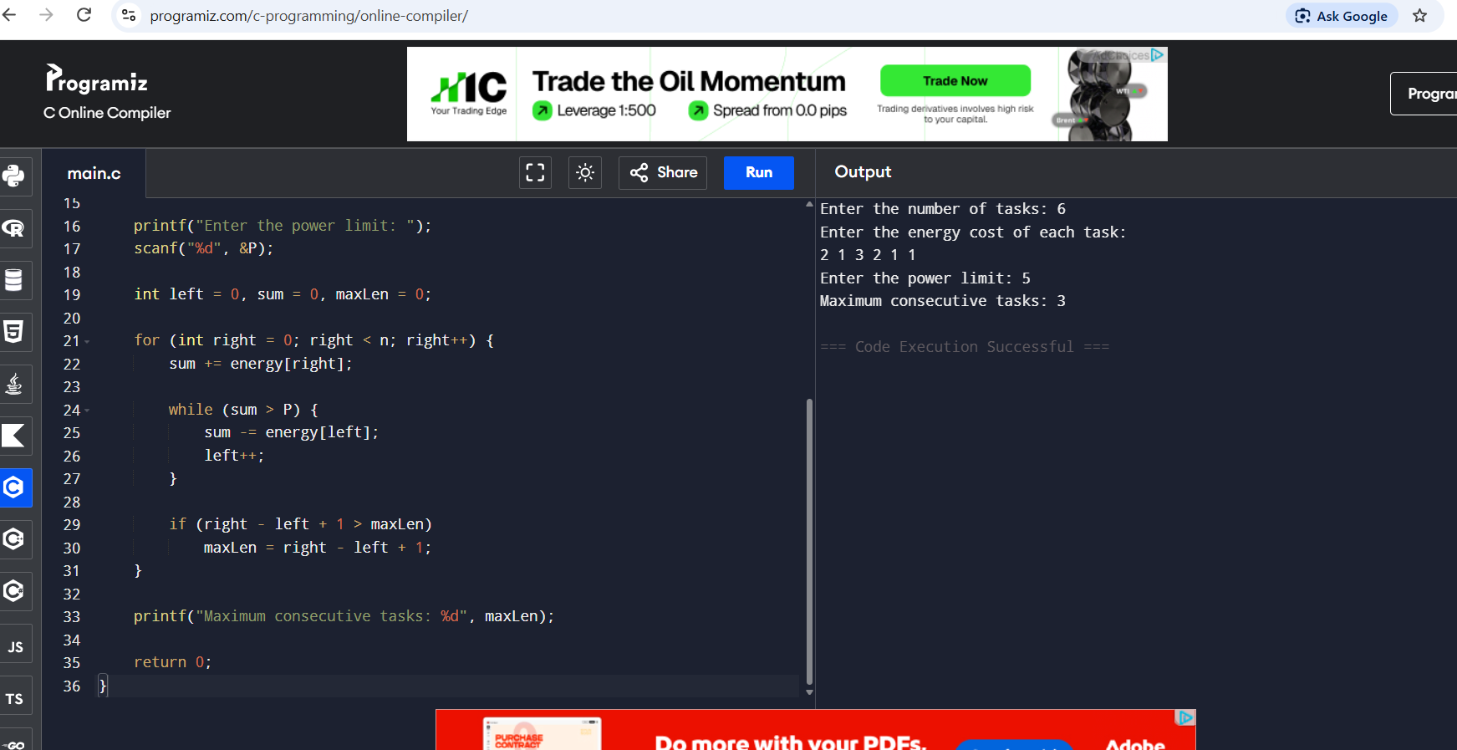

Result: The program correctly computes the longest run of consecutive tasks whose combined energy cost stays within the power limit P, achieving O(N) time using a variable-size sliding window.

Experiment 5: Sliding Window Maximum Peak (Monotonic Deque)

Aim

To write a C program that computes the maximum value in every sliding window of size K across a sequence of frame rendering times, using a monotonic deque for O(N) performance.

Algorithm / Pseudocode
- Read N, K and the N frame rendering times into an array arr. Implement a deque using an array of indices with front and rear pointers.
- For each index i from 0 to N - 1, remove indices from the rear of the deque whose corresponding values are less than or equal to arr[i].
- Insert index i at the rear of the deque.
- Remove the index at the front of the deque if it lies outside the current window (i.e. it is less than or equal to i - K).
- Once i >= K - 1 (the window is fully formed), print arr[deque[front]] as the maximum for that window.
- Repeat until all windows have been processed.

C Program
#include <stdio.h>

int main() {
int n, k;
scanf("%d %d", &n, &k);

int arr[10000];
for (int i = 0; i < n; i++) {
scanf("%d", &arr[i]);
}

int deque[10000];
int front = 0, rear = -1;

for (int i = 0; i < n; i++) {
while (rear >= front && arr[deque[rear]] <= arr[i]) {
rear--;
}
deque[++rear] = i;

if (deque[front] <= i - k) {
front++;
}

if (i >= k - 1) {
printf("%d", arr[deque[front]]);
if (i != n - 1) printf(" ");
}
}
printf("\n");

return 0;
}
Sample Input
4
1 6 7 8
Sample Output
7 8

OUTPUT:

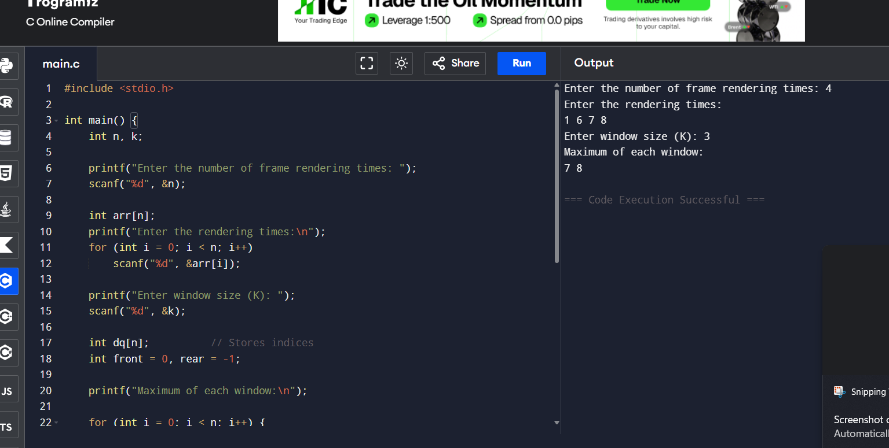

Result: The program correctly reports the maximum rendering time for every sliding window of size K using a monotonic deque, achieving optimal O(N) time complexity instead of the naive O(N*K

